|  |  |  |  |  |  |  |  |
| --- | --- | --- | --- | --- | --- | --- | --- |
| Algorithm | Expected Variance Score | Maximum Error | Mean Absolute Error | Mean Squared Error | Mean Square log error | Median Absolute Error | R2 Score |
| Linear Regression |  |  |  |  |  |  |  |
| Random Forest | 0.84727 | 0.15541 | 0.06245 | 0.00530 | 0.00011 | 0.05941 | 0.84613 |
| Gradient Boost |  |  |  |  |  |  |  |
| SVM |  |  |  |  |  |  |  |
| KNN |  |  |  |  |  |  |  |

**Random Forest:**

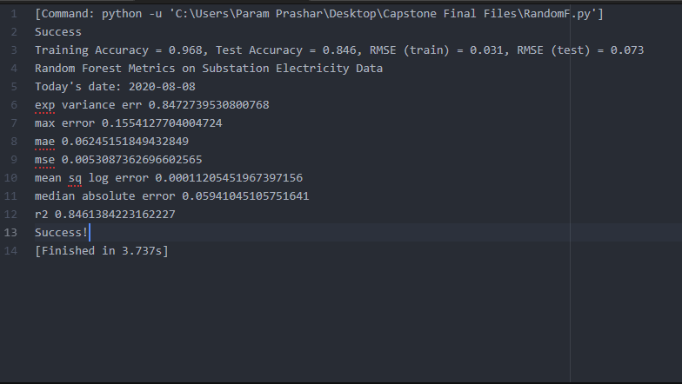

**SVM**

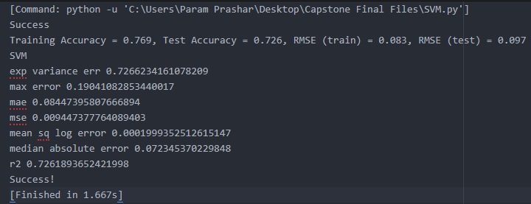

Linear Regression 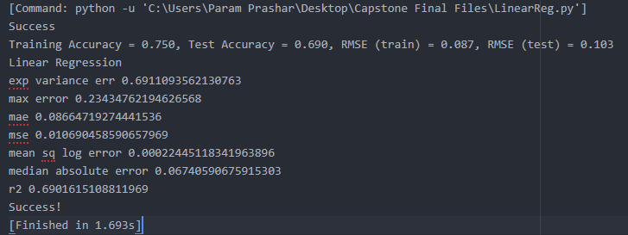

KNN

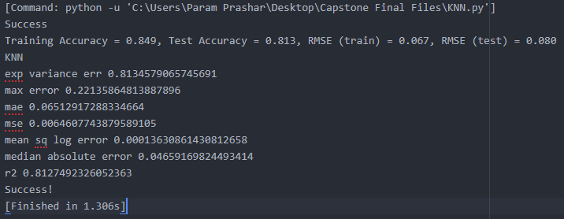

Grad Boost

